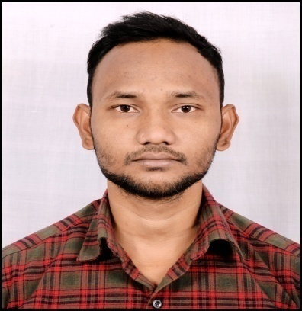

2014 AD (72.4%)

**SEE at Convent secondary English boarding School**

2015 AD (78.6%)

**+2 at Arniko higher secondary English School**

**EDUCATION**

**RANJEET KUMAR SAHANI**

* English
* Nepali

**CONTACT**

+977

[ranjeet.sahani976@gmail.com](mailto:ranjeet.sahani976@gmail.com)

Lahan 56502, Siraha, Nepal **(Home)**



**SOCIAL**

* <https://www.civilconcept.com>
* [www.facebook.com/ranjeet976](http://www.facebook.com/ranjeet976)
* +9779812377976 (Whatsapp)

**LANGUAGE**

1) 10 AUG 2020 – 17 JUL 2022 Lahan, Nepal

**Fruit and veg picker Kalyan Krishi Farm**

* Planting, cultivating, and processing of fruit and vegetable crops.
* Maintained farm machines and prepared soil for different processes.
* Handled the weeding, thinning, and pruning of crops.

2) 11 SEP 2022 – CURRENT Biratnagar, Nepal

**Garden worker Nirman Krishi Farm**

* Operated, maintained, and performed basic repairs on farm equipment.
* Maintaining and cleaning the garden and looking after the health of crops.

**SKILL**

* Knowledge of crop cultivation
* Knowledge of team work
* Knowledge of soil
* Knowledge of farm machinery and equipment
* Knowledge of poultry farming and fertilizing

**WORK EXPERIENCE**

Knowledgeable Farm Worker with drive and experience helping to carry out day-to-day tasks and long-term projects on farms. Adept in the use of farm equipment and machinery, and knowledgeable in a variety of farming procedures. Skilled in soil preparation, irrigation processes, weeding, and pruning crops. Committed to being a positive, flexible, and adaptable team member.

**SUMMARY**

**Date of Birth**: 23 Nov 1995

**Nationality:** Nepalese

**Gender:** Male